Charlotte Cabrera

Professor Eli – M/W/Sat BootCamp

June 26, 2019

Api’s Analysis

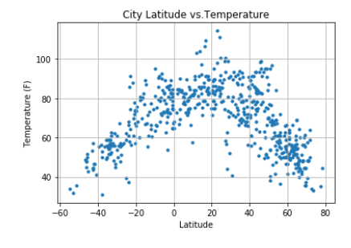

Here the above shows that the closer you get to the equator the temperature does indeed rise and the further away the latitude plots then the cooler the temperature is.

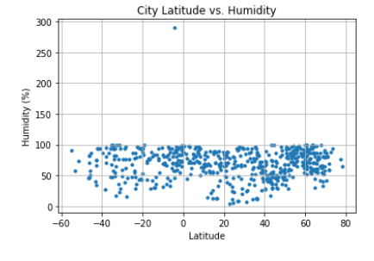

Although this graph shows that humidity is leveled across the board and from -60 to -20 the humidity seem to be less.

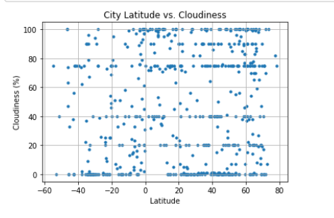

This graph show that Cloudiness and latitude do not have a correlation; as it is pretty even scattered across the board.

Overall, I like the first graph of temperature vs latitude because that supports our hypothesis of the closer we are to the equator the hotter it gets.